What is Forest school?

Middle Barton School
WHAT IS THE FOREST SCHOOL APPROACH TO LEARNING?
‘Forest School is an inspirational process that offers ALL learners regular opportunities to achieve and develop confidence and self-esteem through hands-on learning experiences in a woodland or natural environment with trees’.
(Forest School Association)

Whilst its roots are planted firmly in our best understanding of the theory of how children learn, its practice puts the learner at the heart of their learning experience. From this fundamental platform, Forest School offers children and young people the opportunity, over repeated visits, to engage with the rich natural diversity of the woodland environment to help build confidence, sensitivity, resilience and curiosity.

Forest School is based more on the process of learning than it is on the content - more on the 'how' than the 'what'. This means that genuine Forest School practice steps boldly out of the shadow and limitation of 'planned activities' and ventures collaboratively into the realms of the unplanned, unexpected and ultimately unlimited.

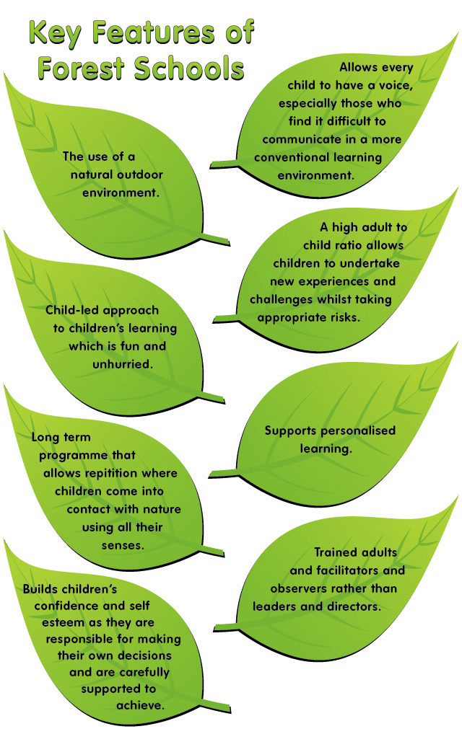
WHAT IS THE FOREST SCHOOL ETHOS?
The Forest School ethos aims to:
- Offer all children the chance to be themselves
- Give children time and space to explore, investigate and invent
- Promote a love of learning and the outdoors
- Encourage independence
- Promote self-esteem and self-confidence
- Develop self-motivated and reflective learners
- Promote collaborative learning and social interaction
- Support emotional intelligence
- Promote a growth mind-set by supporting children outside their comfort zone in order to challenge themselves
- Provide opportunities for children to manage and take appropriate risks
- Promote positive behaviour within Forest School, the classroom and wider community

HOW DOES FOREST SCHOOL SUPPORT HOLISTIC DEVELOPMENT?
WHAT IS HOLISTIC DEVELOPMENT?
A holistic approach to child development and education attempts to address all aspects of a child’s development simultaneously. It aims to develop every child’s intellectual, emotional, social, physical, artistic, creative and spiritual potentials.

HOW IS HOLISTIC DEVELOPMENT FACILITATED THROUGH FOREST SCHOOL?
In order to support children’s holistic development, it is important to create an open and free environment where children’s natural curiosity of nature and intelligence is encouraged; that encourages children to develop a sense of responsibility and to problem solve and ask questions. Forest School is the ideal environment to offer this.
Forest school promotes a child’s holistic development by offering a range of opportunities for development in all areas. It is encompassed within principle 3:
‘Forest School aims to promote the holistic development of all those involved, fostering resilient, confident, independent and creative learners’ (Forest School Association, 2016).
Holistic development is promoted throughout children’s education. The ‘Characteristics of Effective Learning’ which states that children require a rich, enabling environment and positive relationships in order to learn and grow (Early Education, 2012).
The EYFS Characteristics of Effective Learning-
These characteristics are vital throughout a child’s education. Forest School promotes this approach to learning throughout each session.
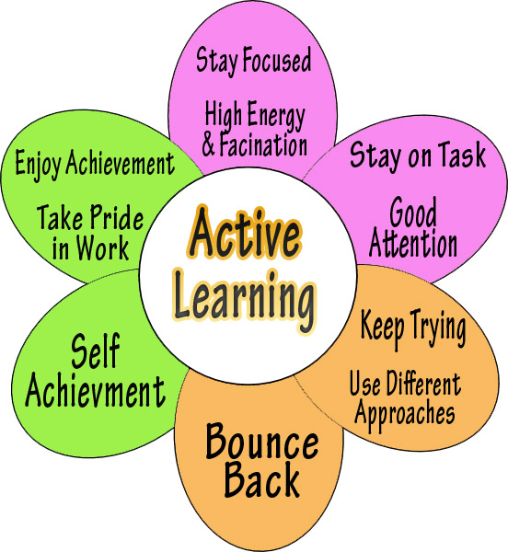

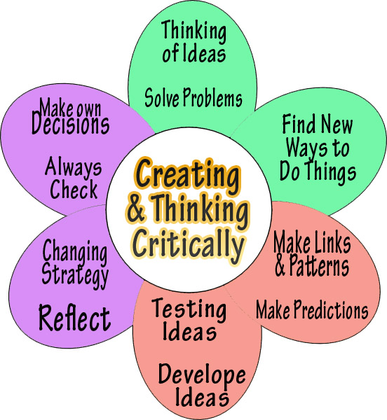

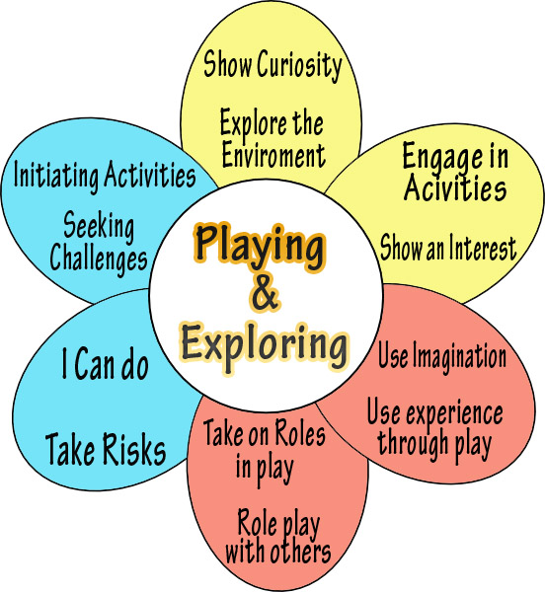

Area of development | Forest School
- Intellectual | Natural curiosity; asking and answering questions; problem solving; independence; decision making; den building; using tools; knowledge of flora and fauna; understanding of safety procedures, challenge and risk…
- Emotional | Achieving goals and challenges; development self-esteem and confidence; perseverance; growth mind set; collaboration; taking risks; expression; empathy; resilience; achievement and success…
- Social | Language skills; communication (verbal and non-verbal); sense of community; developing positive relationships; team work’ collaboration; negotiation; sharing and taking turns; conversation; games…
- Physical | Freedom to explore; creating and making dens, shelters and swings; using tools; building; digging; developing fine and gross motor skills…
- Creative | Creating; using imaginations; playing games; exploring nature in different ways; storytelling; making…
- Spiritual | Community ethos; love of nature; respecting beliefs and other points of views and ideas; caring for the environment…

Find out more about Forest School:

http://www.forestschoolassociation.org

https://www.forestschools.com/

http://www.muddyfaces.co.uk/forest_schools.php

